Campbell County Detention Center Volunteer Packet

In order to ensure your safety as a jail volunteer and to maintain the Campbell County Detention Center’s security integrity, all volunteers entering the Campbell County Detention Center must first pass a security clearance. Please complete the necessary information for a security clearance on the attached sheet. Also attached is a PREA Training Acknowledgment which will need to be signed before entrance to the facility is authorized. Please return these sheets to the detention center at 601 Central Avenue, Newport KY 41071.

Prior to gaining admission to the Campbell County Detention Center, you will be subjected to a criminal background check. By signing the attached form you are hereby granting the Campbell County Detention Center to conduct this background check.

Also enclosed is a list of rules for volunteers and an acknowledgment for PREA training. The rules must be followed for your safety and the safety and security of the facility and inmates. If at any time these rules are violated, you will be terminated as a volunteer.

The PREA (Prison Rape Elimination Act) acknowledgement is in accordance with a Federal Law established to address the prevention and elimination of sexual abuse in correctional facilities. In response to PREA, the Campbell County Detention Center has committed to a standard of ZERO-TOLERANCE for all incidents of sexual abuse and sexual harassment. In order to comply with this Federal Law, all volunteers must be trained on the aspects of PREA and sign an acknowledgement.

Campbell County Detention Center Rules for Volunteers

- All volunteers must provide information for a criminal background check. (form attached)
- Any person entering the jail is subject to search.
- Volunteers may not enter the jail under the influence of intoxicants. Any volunteer appearing to be under the influence of an intoxicant will be asked to leave.
- Volunteers must sign in and obtain a visitor’s badge.
- All counseling or ministering shall be conducted in a place designated by facility staff.
- Volunteers may not exchange personal gifts or favors with inmates. This includes dropping off any sort of property or money at any time for any inmate in the Campbell County Detention Center.
- Volunteers may not accept any form of bribe.
- Volunteers may not bring any kind of weapon or item declared as contraband into the facility. (see attached list)
- Volunteers shall not withhold information, which in doing so, threatens the safety and security of the facility, its staff, inmates, or the community. This would include, but is not limited to, any reports of any sexual assault, violations of PREA, or any other information that may affect anyone’s safety.
- Volunteers may not engage in any form of business or profitable enterprise with inmates.
- Volunteers may not mail out going letters for inmates.
- Volunteers may not pass any notes or letters for inmates.
- Prior to entering the facility, volunteers will advise jail staff of any relative or friend that may be incarcerated in the facility.

ITEMS CONSIDERED CONTRABAND
Cigarettes or tobacco of any sort
Any illegal drugs
Cell phones
Knives
Firearms
Food and beverages*
Magazines
Newspapers
Art supplies
Clothing items**
Money
Books***

* Groups wishing to distribute food items to the inmate population must get permission from Jail Administration.

** Groups wishing to distribute clothing items to the inmate population must get permission from Jail Administration.

*** Groups wishing to bring in books for the inmate population must get permission from Jail Administration.

ALL ITEMS BEING LEFT FOR INMATES WILL BE SEARCHED FOR CONTRABAND PRIOR TO BEING DISTRIBUTED.

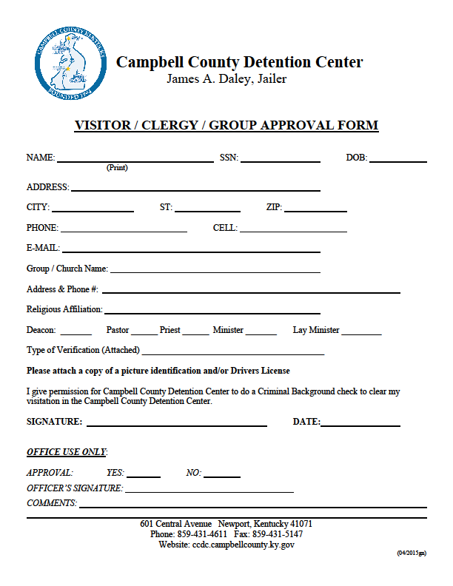
Campbell County Detention Center
Volunteer PREA Training

PREA & Campbell County Detention Center
The Prison Rape Elimination Act of 2003 (PREA) is a Federal law established to address the elimination and prevention of sexual assault in correctional facilities. PREA applies to all federal, state, and local prisons, jails, private facilities, and community settings such as residential facilities. In response to PREA, the Campbell County Detention Center has committed to a standard of ZERO-TOLERANCE for all incidents of sexual abuse or sexual harassment. This includes acts either by staff, other inmates, volunteers, contracted agents, or individuals having custody of or responsibility for the safety, security, or care of inmates. Sexual abuse of inmates by other inmates or staff is prohibited and subject to administrative discipline and criminal charges. Volunteers must be aware that unprofessional relationships will not be tolerated and these relationships are criminal and may be prosecuted under state and federal statutes.
Reporting Requirements and Acknowledgement
All Campbell County Detention Center employees, volunteers, or contracted agents are required to report knowledge of any alleged sexual abuse or sexual harassment where staff, contract agents, volunteers, or inmates are involved. Forms of reporting include advising a deputy jailer, shift supervisor, or the Jailer. My signature acknowledges that I have received training on the Prison Rape Elimination Act of 2003 and understand that the Campbell County Detention Center has a zero-tolerance policy for all forms of sexual abuse and sexual harassment. I have knowledge of all relevant policies that pertain to PREA and all directives therein. I have had the opportunity to ask questions and receive feedback and am satisfied with my understanding of PREA and all its components as it relates to the Campbell County Detention Center.

____________________ _____________________ __________
Volunteer PREA Coordinator Date

